2022/9/10

As you are more familiar with ray tracing than I am, I will not introduce what ray tracing is. Instead, I’ll show you pictures created along the way of creating this project.

This is one of the wrong outputs when I first did the intersection part. Although it is not correct, the dots are quite interesting, I shall try to figure out what meaning is in this picture or what went wrong.

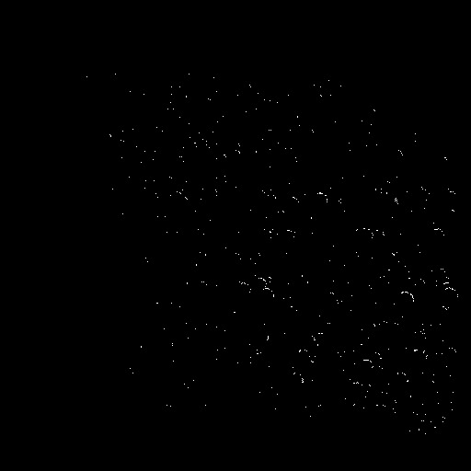

This is the output with only intersection instead and replaced shade with color=hr.f.color

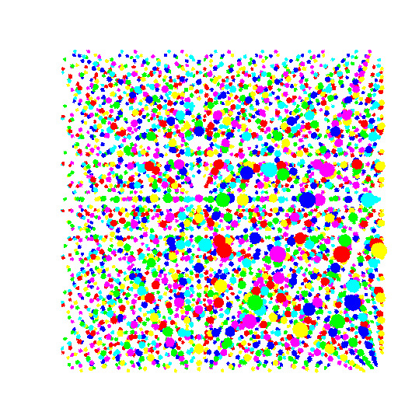

Afterwards, when doing the shade part, I was too anxious at the start and tried to write all the steps together. No matter how I tried to debug, I got pictures like these, either full black or blue.



Then, I deleted all of it and started again testing the parts one by one, and these are the results I got as I added each part.

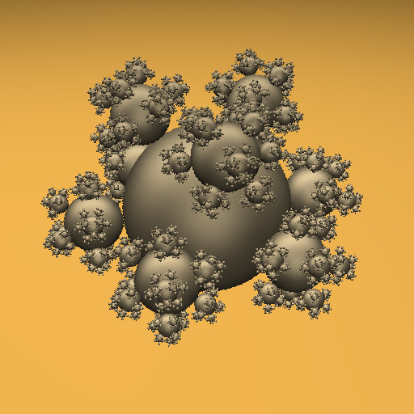

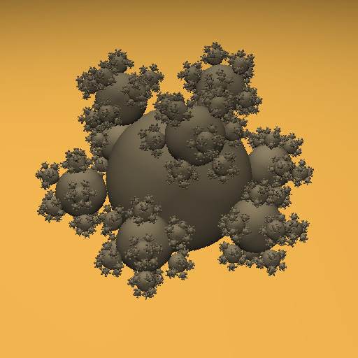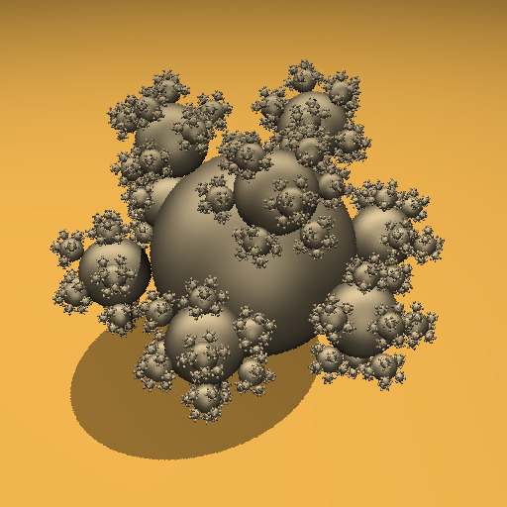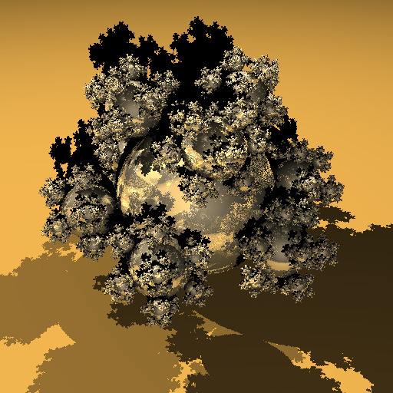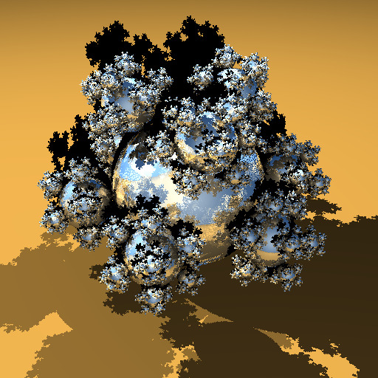

At the end, I would like to thank you for teaching me these few months, It was a very meaningful experience.